Experiment-2

Name of Student:Pratik Masani
Batch: ET-C 1
Roll No:21
Branch:Electronics and Telecommunications
GRN:12111038
There is a class Adder which has two data members of type 1D int array and int variable. It has two functions: getdata and numsum. Function getdata accepts non-empty array of distinct integers from user in 1D int array data member and a targetsum in another data member.
The function numsum adds any two elements from an input array which is equal to targetsum and return an array of resulting two elements, in any order. If no two numbers sum up to the target sum, the function should return an empty array.
Note that the target sum is to be obtained by summing two different integers in the array; you can’t add a single integer to itself in order to obtain the target sum. You can assume that there will be at most one pair of numbers summing up to the target sum. Use constructor. Use extra variables if needed.
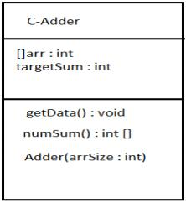
Sample Input and Output
Test Case 1

Input  Parameters | Values | Expected Output
1D Array | [3,5,-4,8,11,1,-1,7] | [8,7]
targetsum | 15 | [8,7]

Test Case 2

Input  Parameters | Values | Expected Output
1D Array | [3,5,-4,8,11,1,-1,6] | [ ]
targetsum | 15 | [ ]

Add your Code Here

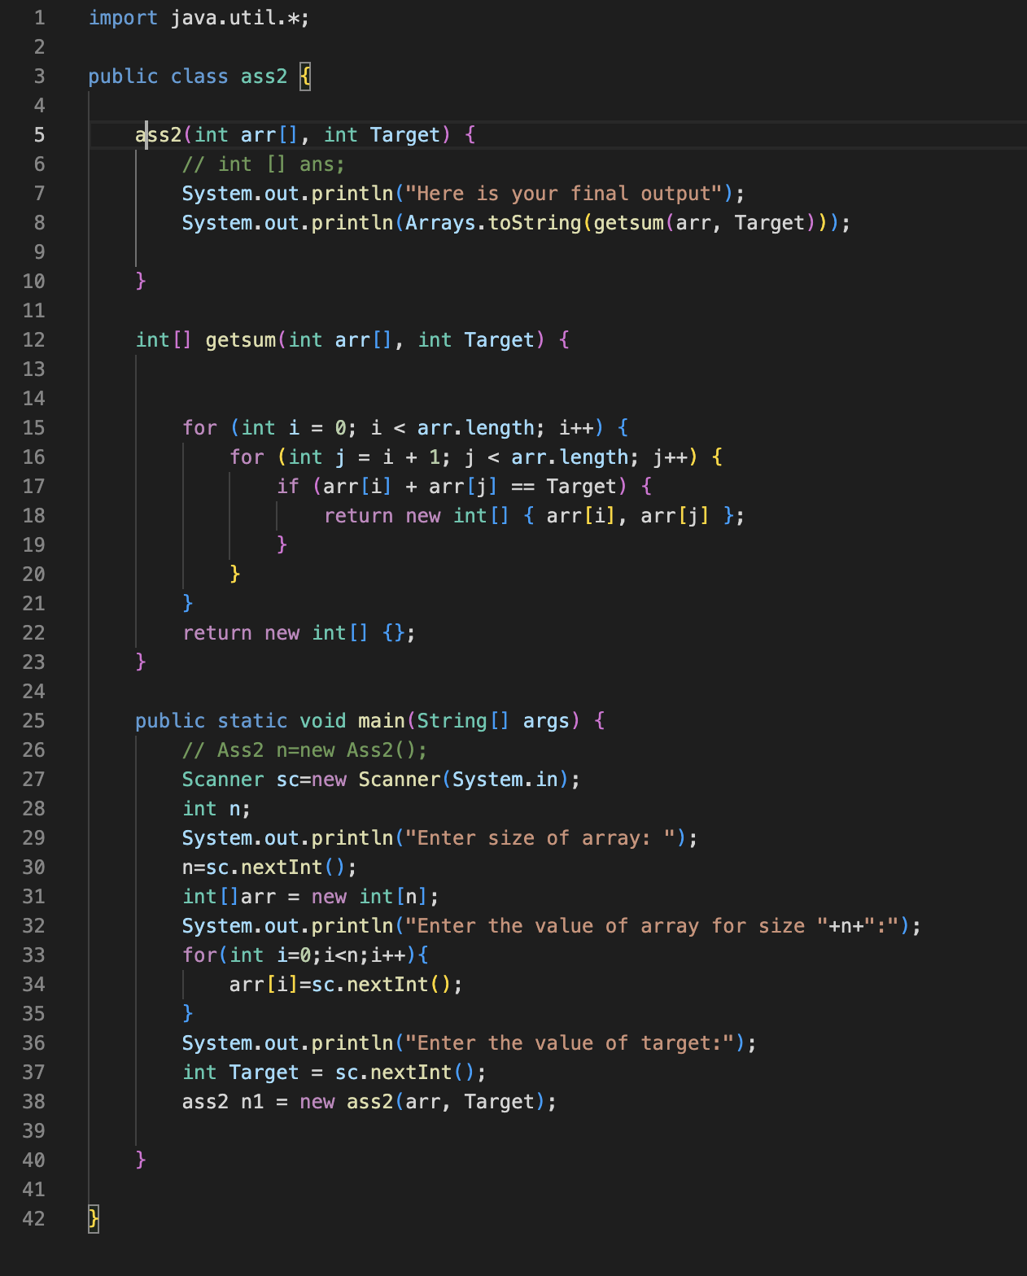

Results:
Actual Output
